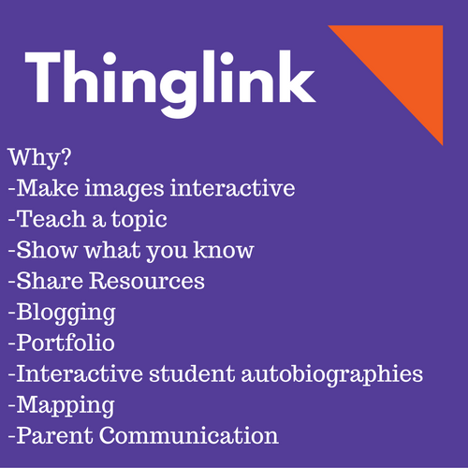
Ways to use thinglink
http://www.freetech4teachers.com/2013/06/65-ways-to-use-thinglink-in-your.html#.WCip8eErLUI

Video tutorial for thinglink
https://youtu.be/zni_dEB9t30

The Thinglink ipad app allows you to record and load video and take photos using the ipad camera.

